1. MongoDB install

* Install Windows 6.1 update
* Unzip the mongodb.zip in local drive C (C:\mongodb\bin\...)  
  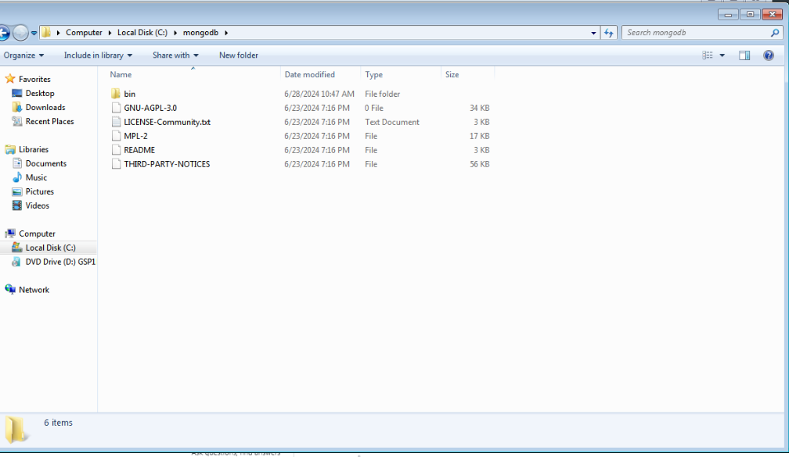
* Go to control panel and find “Edit environment variables for your account”, click Environment Variables, In system variables find path and add “C:\mongodb\bin”(here be careful not to delete the system variables in path)   
  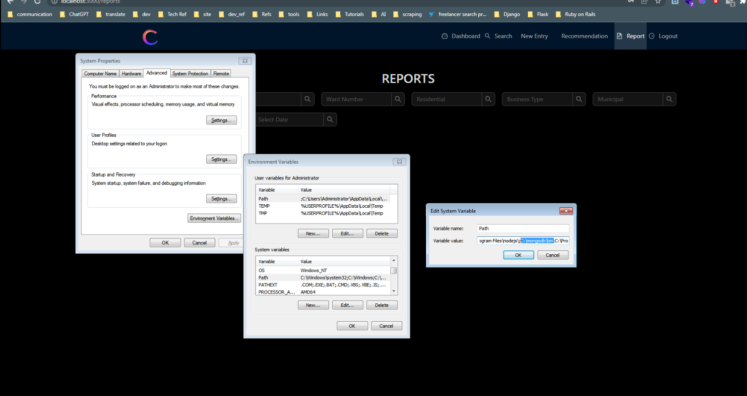
* create an empty folder named db in local drive C
* Run cmd and “ mongod --port 27017 --dbpath “C:\db”  
  If success, you will get this dialogue

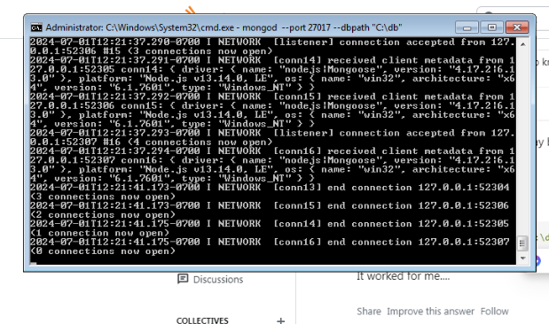

1. Node.js Install and project run

* Install Node 13.14 (after install you can check by running node -v in cmd)
* Unzip the adminapp.zip, go into server and run cmd and “npm install”, after installed, npm run server.

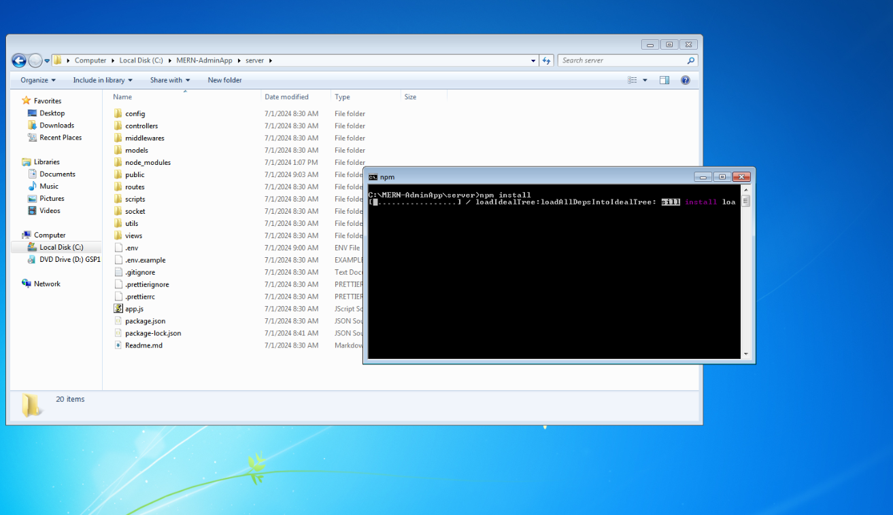  
If server working correctly, “MongoDB connected message appears” in cmd.

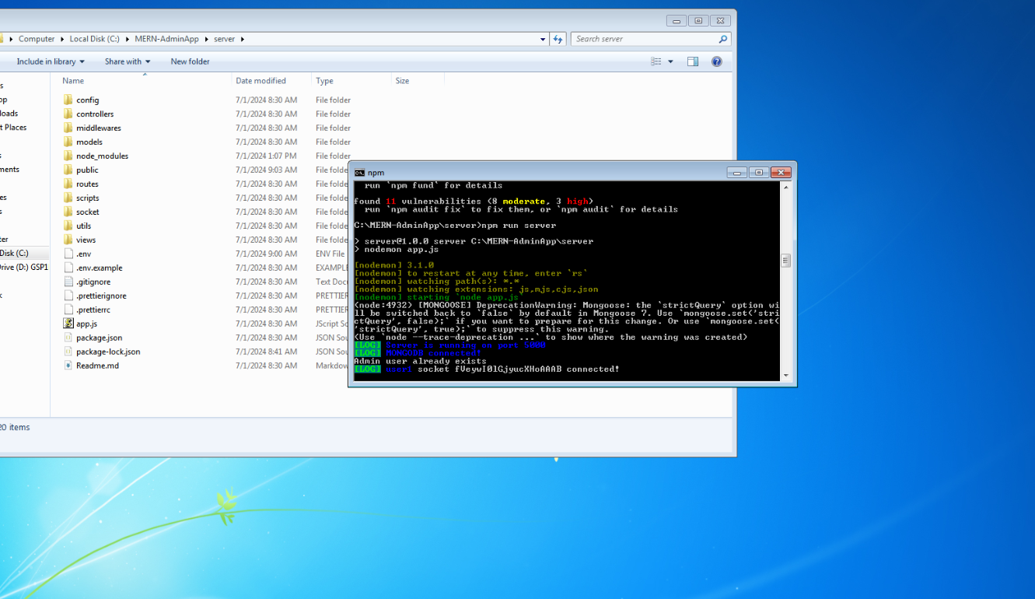

* Go into client, run cmd and “npm install”.

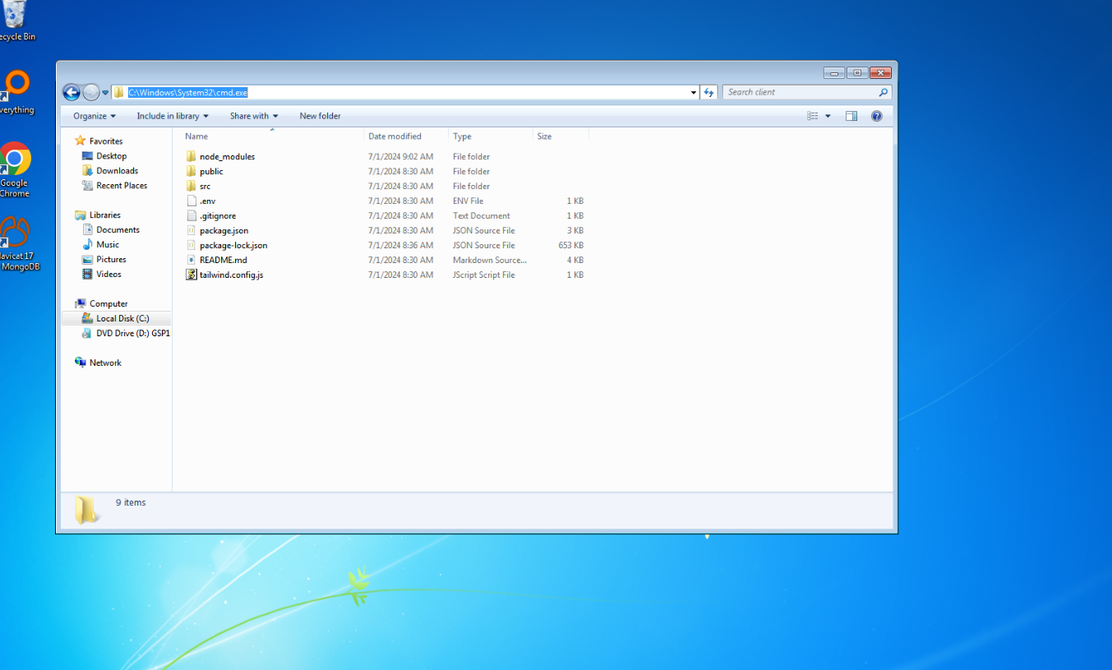

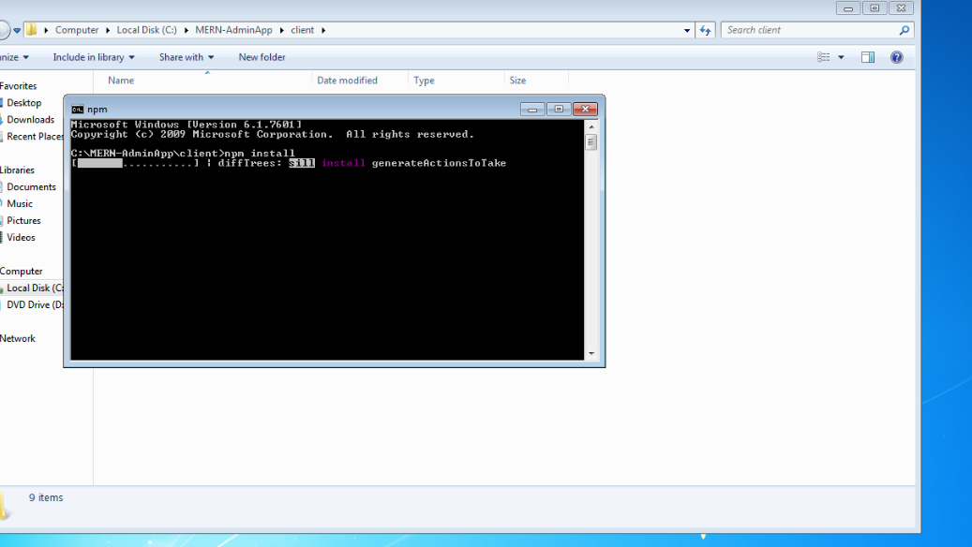  
After installed, run “npm run start”

Application will be run in browser localhost:3000

